Lab 05

TASK 01:
Trace the supplied tree by hand using Minimax
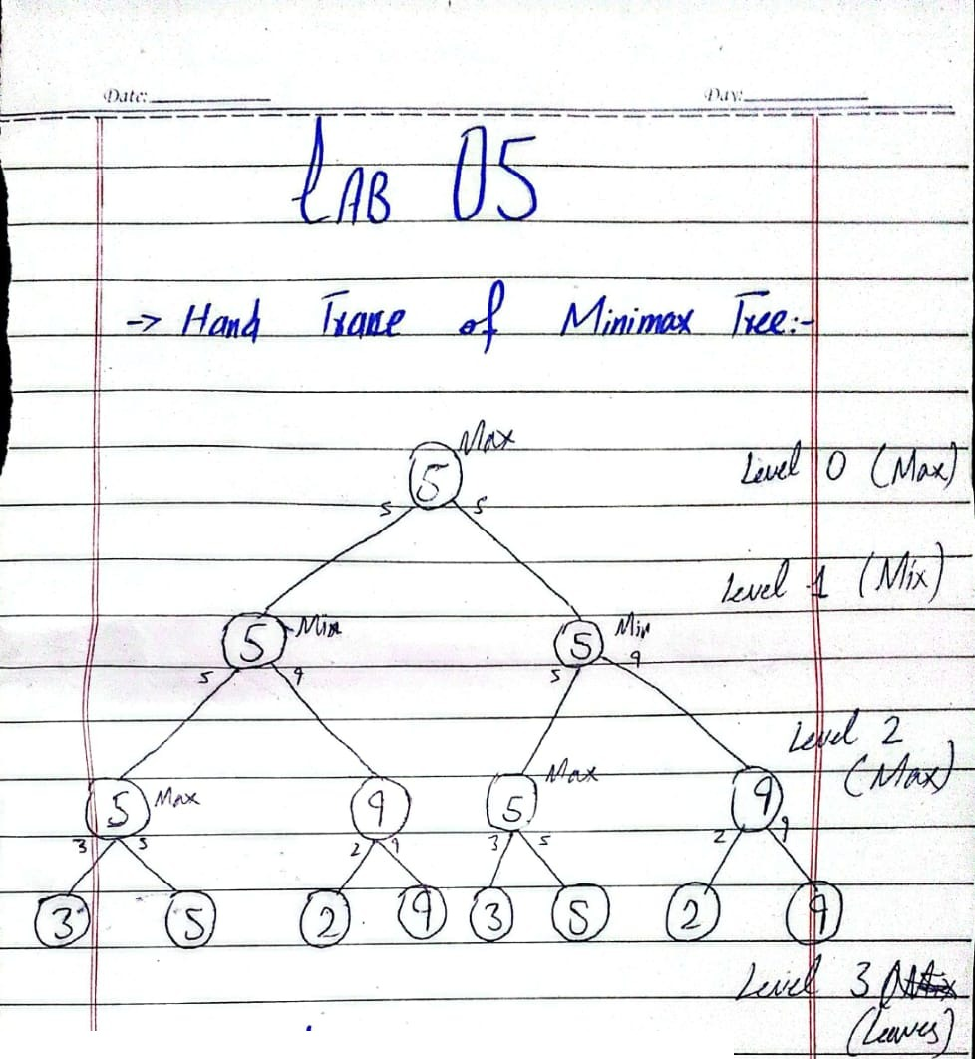
Level 3 (Leaves): 3, 5, 2, 9, 3, 5, 2, 9
Level 2 (Max): Left half: max(3,5) = 5 & max(2,9) = 9. Right half: max(3,5) = 5 & max(2,9) = 9.
Level 1 (Min): Left: min(5,9) = 5. Right: min(5,9) = 5.
Level 0 (Max): Root = max(5,5) = 5 soo the optimal Minimax value is 5.

Task 02: Add a leaf-evaluation counter to both algorithms
I added two counters leaves_mm for Minimax & leaves_ab for Alpha-Beta. Both start at zero. Are reset before every test. Each counter increases by one inside base case that is every time the function reaches a leaf & evaluates its score. This shows how work each algorithm does.

Counter in Minimax:
leaves_mm = 0

def minimax(curDepth, nodeIndex, maxTurn, scores, targetDepth):
global leaves_mm
if curDepth == targetDepth:
leaves_mm = leaves_mm + 1
return scores[nodeIndex]

Counter in Alpha-Beta:
leaves_ab = 0

def alphabeta(depth, index, maxTurn, scores, target, alpha, beta):
global leaves_ab
if depth == target:
leaves_ab = leaves_ab + 1
return scores[index]

Output for the supplied tree [3,5,2,9,3,5,2,9]:
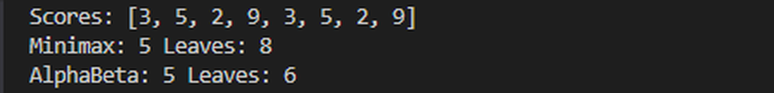

Both algorithms return root value of 5. The Minimax algorithm evaluated all eight leaf nodes. The Alpha-Beta algorithm evaluated six leaf nodes bcz it pruned leaves with values 2 & 9 on the right side. Pruning happened bcz those branches could not affect the decision. This shows that Alpha-Beta is more efficient. It avoids work while still finding the correct answer.
Task 03: Reorder branches and observe pruning
I reordered the leaves in four ways: normal, best, worst & all-equal. Then I ran both algorithms on each of those setups. The root value didn’t change all. It stayed same every time. The only thing that changed was how many leaves got evaluated.

Output task_5.py

Level | Scores List | Root Values | Minimax Leaves | Alpha-Beta Leaves
Normal | [3,5,2,9,3,5,2,9] | 5 | 8 | 6
Best Order | [5,3,9,2,5,3,9,2] | 5 | 8 | 5
Worst Order | [2,9,3,5,2,9,3,5] | 5 | 8 | 8
Equal (Edge Case) | [4,4,4,4,4,4,4,4] | 4 | 8 | 5
Padded / Mixed Case | [3,5,2,9,0,7,0,0] | 5 | 8 | 6 (or depending on exact output)

Task 03: Explanation, Edge Case & Limitation:

Explanation: Both Minimax and Alpha-Beta gave the root value in every test. That means pruning does not change the decision made by Minimax. Minimax always checks all 8 leaves no matter what. Alpha-Beta behaves differently depending on the order of the leaves. In the order Alpha-Beta checks only 6 leaves. On the side the first Max node gave a value of 5. That sets beta to 5. The left side already has alpha at 5. Since alpha is greater than or equal to beta the remaining branch. The leaves 2 & 9. Gets pruned. So Alpha-Beta skips them………
Reordering: In the Best Order [5,3,9,2,5,3,9,2] the better values come first in each MAX pair. Bcz of this pruning happens early. Alpha-Beta checks 5 leaves which is the minimum possible for this tree. In the Worst Order [2,9,3,5,2,9,3,5] the worse values come first. No pruning happens all. Alpha-Beta checks all 8 leaves like Minimax. The root value stays 5 in every case. Only the number of leaf checks changes……..
Edge Case: There an edge case too. When all leaves have value like 4. The code uses alpha >= beta to trigger pruning. Even ties cause pruning. For example on the side after the first MAX pair alpha & beta both become 4. Soo the rest of the branch is skipped. Alpha-Beta checks 5 leaves same as in the best case.. Minimax still checks all 8 leaves….
Limitation: The code only works for binary trees where the number of leaves is a power of 2. If the tree is not like that the scores list must be padded. For instance it’s padded with zeros like [3,5,2,9,0,7]. The fake padded scores can affect the result. Also this tree only has 8 leaves.. On larger trees the savings from pruning……..

Reflection:
1-What did you learn today?
How Minimax finds the best value & how Alpha-Beta pruning skip useless branches.

2-How will you apply this in a real AI system?
In games Chess or Tic-Tac-Toe to choose moves faster.

3-What failed or surprised you?
Changing leaf order changed checked leaves from 8 to 5 while the final answer 5.

4-What would you do differently next time?
Test this on larger game tree.

5-Responsible practice (Transparency)
I showed the tree, the scores, the leaf counts & pruning decisions soo another student can reproduce the chosen move and verify the result.

Problem Phase:

Jab yeh task mila toh shuru mein thora mushkil laga, isliye maine sab se pehle AI ki madad se concepts clear kiye, YouTube par Minimaz aur Alpha Beta ki videos dekheen aur content jama karke code likhna shuru kiya. Rastay mein thori pareshaniyan aaeen lekin 1 din tak poori tarah task ko samajhne ke baad, agle 2 din lagataar baith kar code mukammal kiya, doston ya zaroorat ke mutabiq pooch kar cheezon ko behtar banaya, aur phir GitHub par bhi successfully upload kar diya. Iske baad jab sir se confirm kiya toh unho ne kaha ke grading woh baad mein karein ge, ishi beech class se ek din pehle raat ko baith kar kaam mein kuch mazeed updates aur changes bhi kar deen taaki sab kuch bilkul perfect ho jaye.

